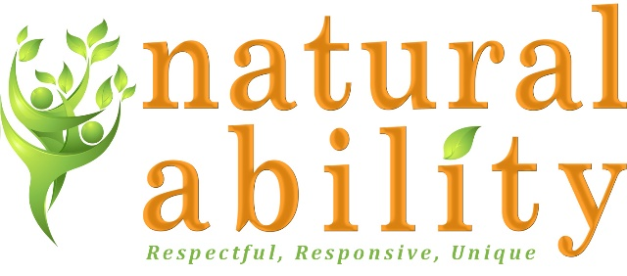

Job Description
Role | Activity Supervisor
Salary | £12.82 per hour
Responsible to | Day Services Manager
Responsible for | Volunteers

About Natural Ability
Natural Ability is a Registered Charity and Company Limited by Guarantee providing agricultural and animal care work, arts, crafts and cookery skills training, and other skills development, education and Supported Living for adults with learning disabilities.
Natural Ability aims to:
- Support the personal development and autonomy of people with learning disabilities.
- Offer work which is meaningful, productive, dignified and challenging.
- Develop environmentally sustainable ways of living and working.
- Ensure that people with disabilities are seen as an important part of the community.
Job Purpose:
The role will involve supporting a group of people with learning and other disabilities to undertake activities both indoors and outdoors including horticulture, animal husbandry, wood working, agriculture, crafts, art, cooking or other similar activities. Working under the guidance of the Day Services Manager the role will actively promote the independence and skills development of adults with learning disabilities.
Day Services
The service runs Monday to Friday and offers a range of work experience, training and opportunities and qualifications for adults with learning disabilities, including those with complex needs. Work includes creating gardens, growing plants, wood working, woodland management, environmental studies, educational walks, animal husbandry, arts, crafts, cooking and other activities.
Main Duties and Responsibilities:
- To lead Day Services activity sessions working with groups of individuals
  - Work with the Day Services Manager and wider staff team to develop seasonal activities to be delivered at our centre in Hexham and a number of other venues within Northumberland.
  - Work with venue staff to identify appropriate work for attendees to help with whilst ensuring welfare of attendees is promoted.
  - Encourage people who attend sessions to interact with others where appropriate and work as a team as far as they are able.
  - Manage incidents of challenging behaviour which may be experienced by people who attend sessions in a respectful and positive way
- To support Day Services attendees to access qualifications if appropriate
  - Under instruction from the Day Services Manager, identify individuals who wish to engage with ASDAN qualifications.
  - Support the attendees to complete tasks, activities and records to support their learning.
- To support with the monitoring of individual progress and the overall effectiveness of the Day Service.
  - Monitor and record each session completing the appropriate administration to ensure this is captured.
  - Gather information and evaluation data as required to contribute to setting, monitoring and reviewing individuals’ personal goals.
  - To contribute to the maintenance of up-to-date records of clients and their progress within Day Services.
- Expand the service.
  - To support the Day Services Manager to promote and publicise the benefits of the day services and increase the number of people using the services.
  - To support with the identification of new activity sessions and venues.
  - Assist the Day Services Manager with the recruitment and induction of Day Services volunteers.
- Partnership Working.
  - To establish and maintain positive relationships with venue staff and other members of the communities in which Natural Ability Day Services operate in.
  - To establish and maintain positive relationships with people with disabilities, their families and carers.
  - To work effectively with external colleagues where someone using the service requires additional support
- Manage Health & Safety and Risk
  - To understand the principles of Safeguarding and reporting.
  - To support the Day Services Manager with the completion of risk assessments for clients and venues.
  - To ensure that Health and Safety and all other Policies and Procedures are followed.
  - To ensure the day service vehicles are checked prior to each session to ensure they are safe, legal and maintained to an appropriate standard.
  - To use equipment and resources safely to meet needs of the service.
- Other duties as required by business need.
  - To actively promote inclusive practice to ensure acceptance of people with disabilities in the community.
  - To have challenging expectations that encourages people to act independently and build self-esteem.
  - Attend and participate in staff meetings and participate in supervision and appraisal as required
  - Follow financial procedures
  - Participate in training and development, and activities that contribute to the management of performance
  - Comply with all Natural Ability policies and procedures in all aspects of work
  - Maintain confidentiality according to Natural Ability’s policies and procedures
  - Undertake other duties and responsibilities as required commensurate with the grade of the post.
Benefits of working with Natural Ability:
- Competitive pay rates.
- Mileage allowance.
- Option to work additional hours.
- Fully paid induction.
- Support with personal development.
- Employer contribution pension scheme.
- Employee Assistance Programme.
- 24 hours’ management and on call support.

Person Specification
 | Essential | Desirable
Skills, Knowledge, qualifications | Excellent communication skills  Ability to work well with people with learning and other disabilities  Understanding of the needs of vulnerable people  Knowledge of issues around Safeguarding Vulnerable Adults  Understanding of needs of working in a rural environment  Understanding of Confidentiality  Ability to travel to meet the requirements of the post  Good IT skills | Level 3 NVQ/other qualification in related discipline  HSAW First Aid Certificate or equivalent  Moving and Handling training  Qualification in specific non-verbal communication aids eg Makaton
Experience | Experience of supporting groups of individuals.  Planning activities / sessions for groups.  Willing to drive a mini bus (training may be available) | Working with and for people with disabilities  Working on a farm/rural project  Animal care work, including work with farm animals  Wood working or craft skills  Arts and crafts skills  Cooking skills  Volunteer staff management  Supporting individuals with learning disabilities to access the community
Personal qualities | Commitment to the ethos of Natural Ability  Willingness to participate in development and training opportunities  Creativity  Able physically to meet the demands of the job  Commitment to animal welfare  Happy to “get your hands dirty” and work outside in all weathers  Commitment to excellent care for disabled people  Commitment to the participation and empowerment of people with disabilities  Reliability  Flexible approach  Conscientious and motivated  Demonstrate a positive, buoyant, flexible approach to their work  Car driver. Full, clean driving licence, business use insurance and access to a car

Natural Ability is committed to safeguarding children and vulnerable adults and all successful applicants will need to submit to a DBS check at the Enhanced level.

