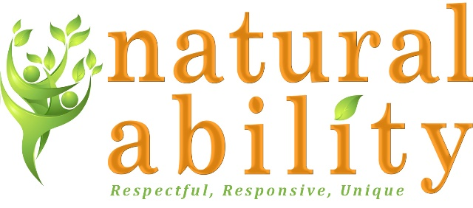

Job Description
Role | Independent Supported Living (ISL) Worker
Reference No. | ISL – 05 2020
Terms | 22.3 hours
Salary | £8.47 per hour
Responsible to: | ISL Manager
Responsible for: | Individual/s with learning disabilities living in their own home.

About Natural Ability
Natural Ability is a Registered Charity and Company Limited by Guarantee providing agricultural and animal care work, training, education, holidays and Supported Living for children and adults with learning disabilities.
Natural Ability aims to:
- Support the personal development and autonomy of people with learning disabilities.
- Offer work which is meaningful, productive, dignified and challenging.
- Develop environmentally sustainable ways of living and working.
- Ensure that people with disabilities are seen as an important part of the community.
Job Purpose:
- To support people with learning and other disabilities to live as independently as possible in their own home.
- To provide supervision, education and support to people with learning disabilities to undertake personal care, cooking, cleaning and daily living tasks
- To promote the independence and personal and skills development of people with disabilities
- To promote the inclusion of people with learning disabilities in the community, supporting them to live the life they choose.
- To support people with learning disabilities to make choices and to be empowered

Main Duties and Responsibilities:
- To supervise and support daily life for people with disabilities in a respectful and positive way.
- Assist with planning, monitoring, recording and evaluation of support.
- To work within a lifelong learning framework.
- To support their personal care to a high standard.
- To develop and promote independence.
- To maintain the safety of people with learning disabilities at home.
- To promote the health and wellbeing of people with disabilities.
- To maintain effective working relationships with other agencies, carers and family of people with learning disabilities.
- Undertake any necessary training, as appropriate to the role.
- To work to Natural Ability Policies and Procedures.
- Ensure that Health and Safety and all other Policies and Procedures are followed.
- To develop and promote the inclusion of people with disabilities.
- To adhere to all financial procedures.
- Carry out house co-ordinator duties which involves carrying out administration duties, record keeping and audits to ensure compliance with policies and procedures.
- Undertake any other reasonable duties as required.
Benefits of working with Natural Ability:
- Competitive pay rates.
- Mileage allowance.
- Option to work additional hours.
- Fully paid induction including training and practical shadow shifts.
- Support with personal development.
- Employer contribution pension scheme.
- 24 hours’ management and on call support.
Person Specification
 | Essential | Desirable
Skills, Knowledge, qualifications | Excellent communication skills.  Understanding of the needs of vulnerable people.  Ability to travel to meet the requirements of the post.  Basic IT skills. | Level 3 NVQ / other qualification in related discipline.  Knowledge of issues around Safeguarding vulnerable adults.  Knowledge of DoLS and mental capacity assessment.  Current UK driving licence and business insurance.
Experience | Supporting people with complex needs.  Positively managing challenging behaviour.  Delivering personal care.  Experience in record keeping and evaluation. | Experience of working with and for people with learning disabilities.  Providing support for vulnerable people in their own home.  Working with complex mental and physical health needs.
Personal qualities | Commitment to the ethos of Natural Ability.  Commitment to excellent care for disabled people.  Commitment to the participation and empowerment of people with disabilities.  Conscientious and motivated.  Sensitivity and empathy.  Positive and buoyant approach. | Comfortable in social situations.  Enjoy being physically active.

Please note that Natural Ability is committed to safeguarding children and vulnerable adults and all successful applicants will need to submit to a DBS check at the Enhanced level.

